Lab 4

Tony Sommer

I had trouble getting the web services into the IIS. Whenever I tried to copy the folder it said I didn’t have permission.

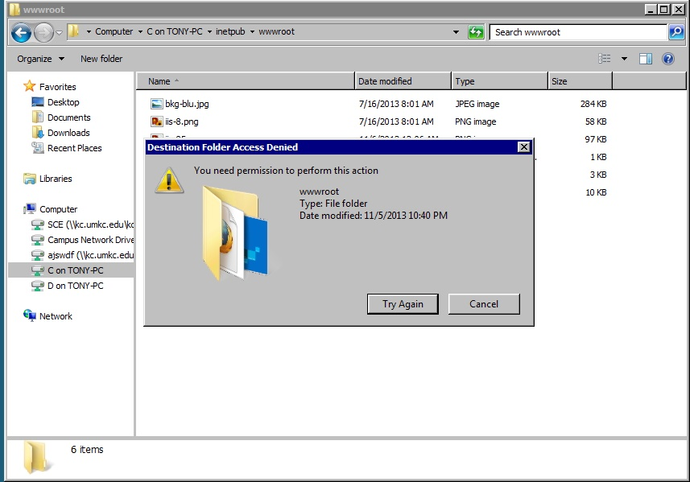

So I wasn’t able to deploy my web services and use them, but they were still developed. One was a simple function that added two numbers together.

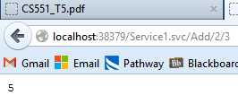

The other SOAP web service used the database to display the first name and last name of the entries in the database, where the database had an id (which is the input to the web service), first name, and last name.

I also started an Android app, but I didn’t develop it much since my web services didn’t work.